# Day 1 (14 - 05 - 2025)

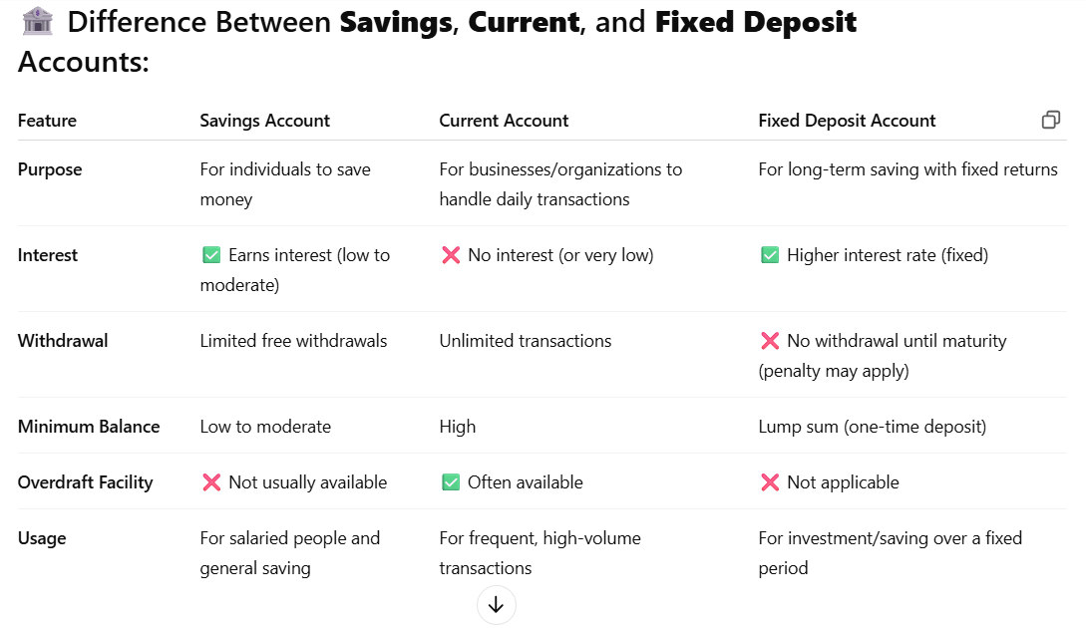

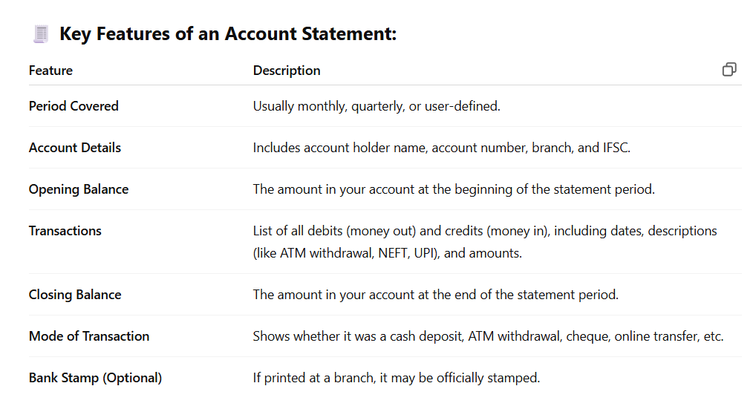

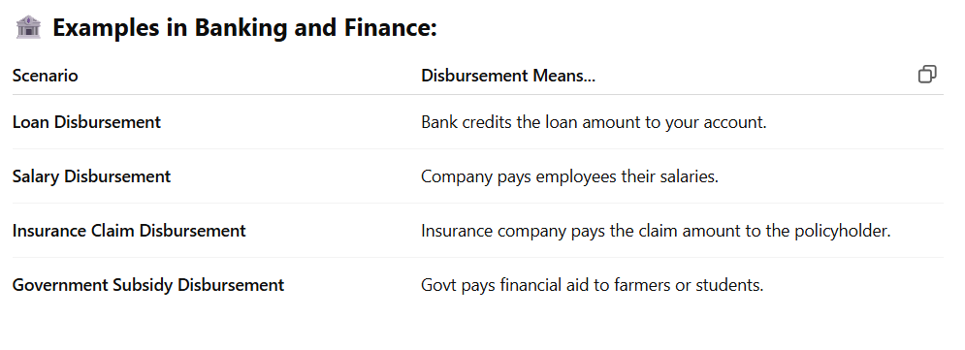

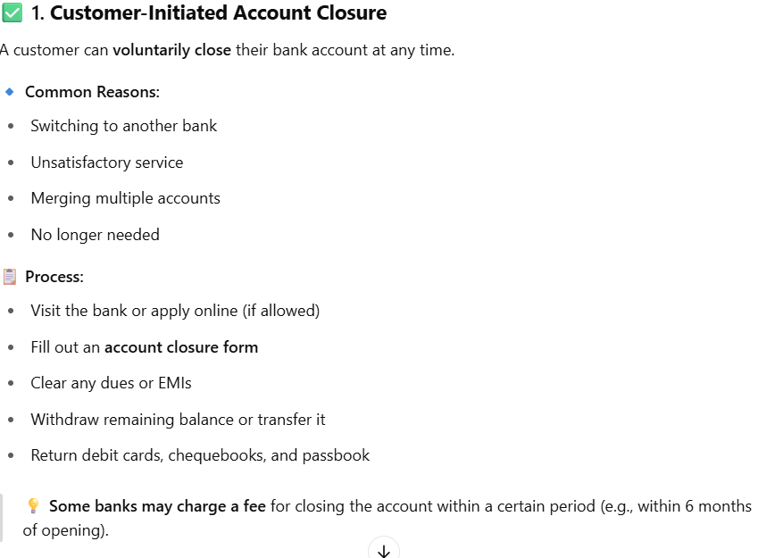

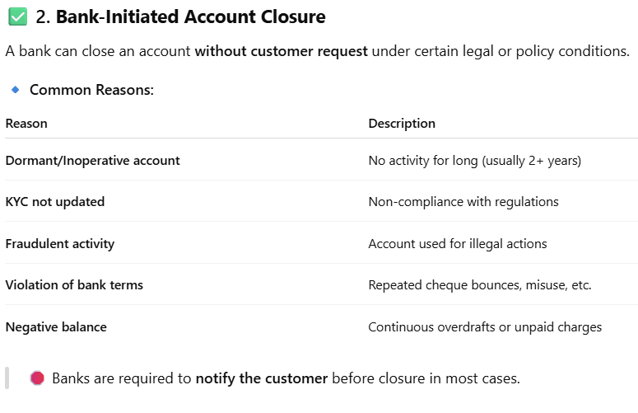

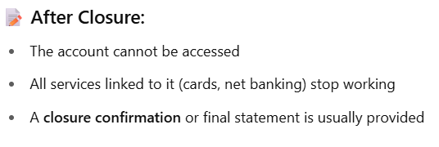

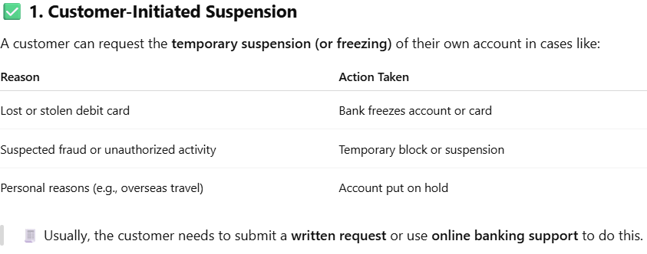

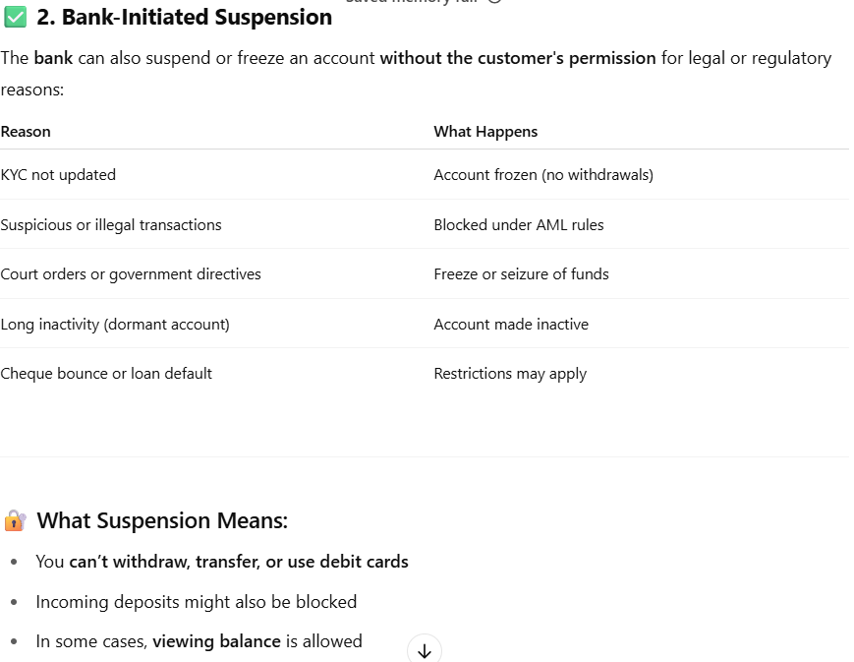

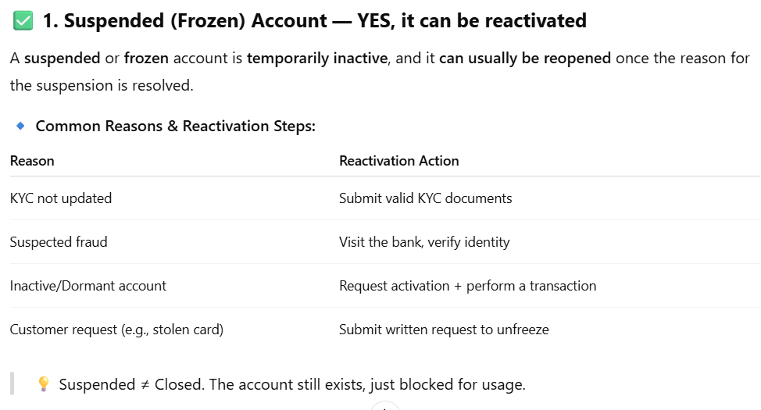

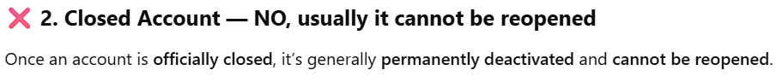

# Day 2 (15 - 05 - 2025)

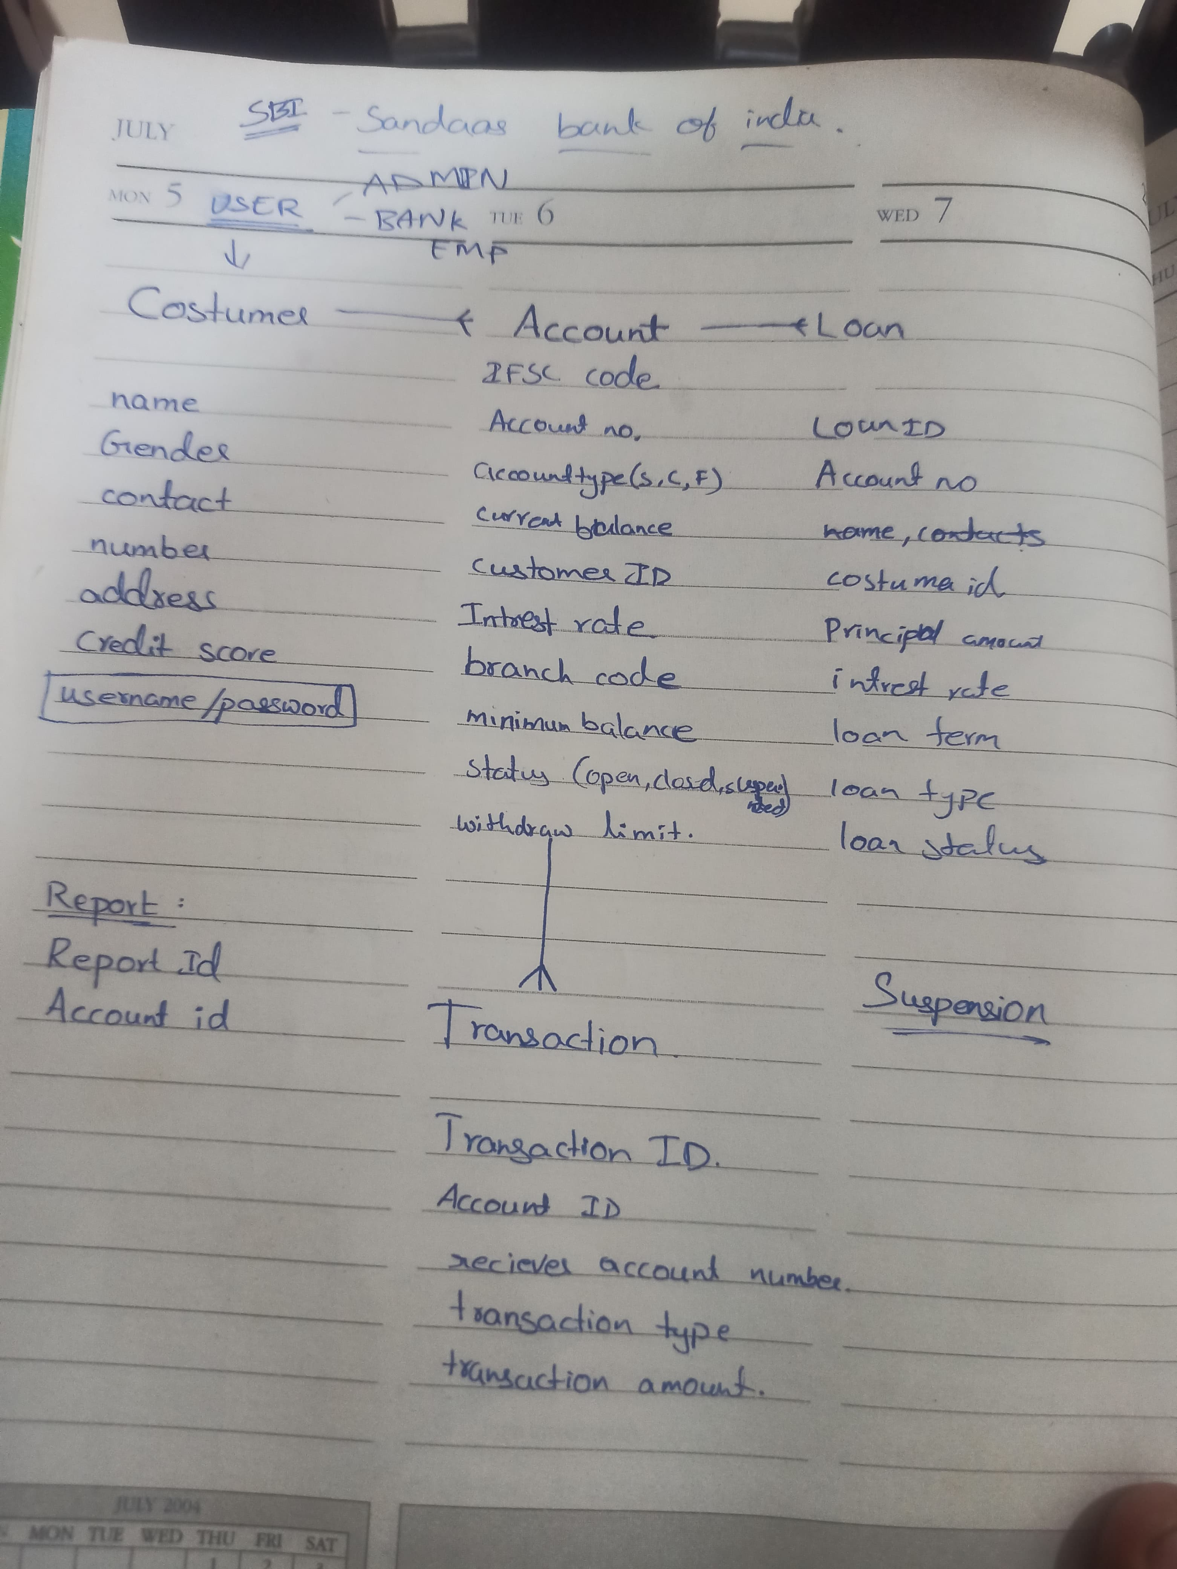

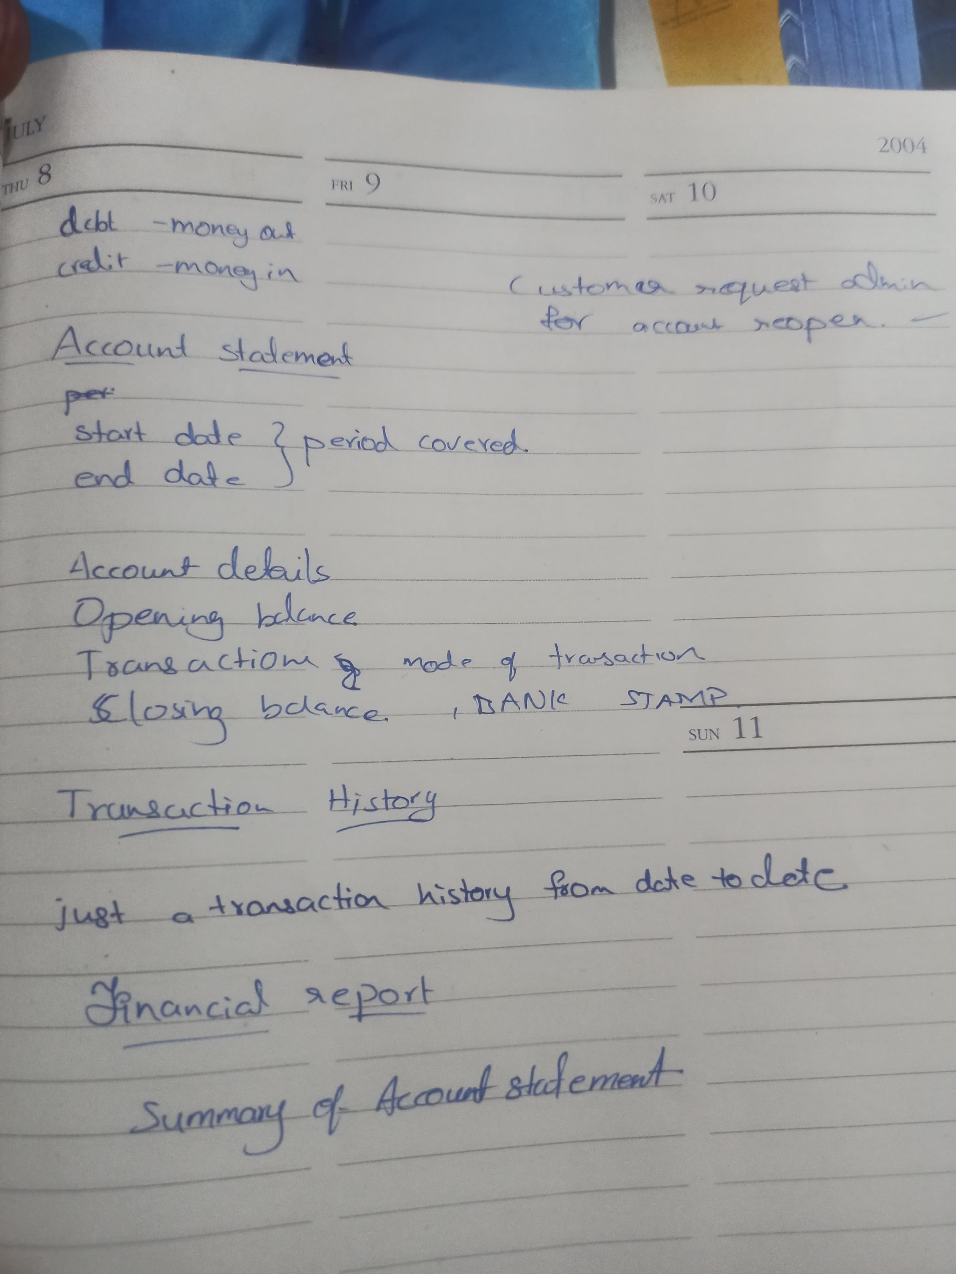

# Day 3 (16 - 05 - 2025)

**REGULAR EXPRESSION CHECK IN SQL**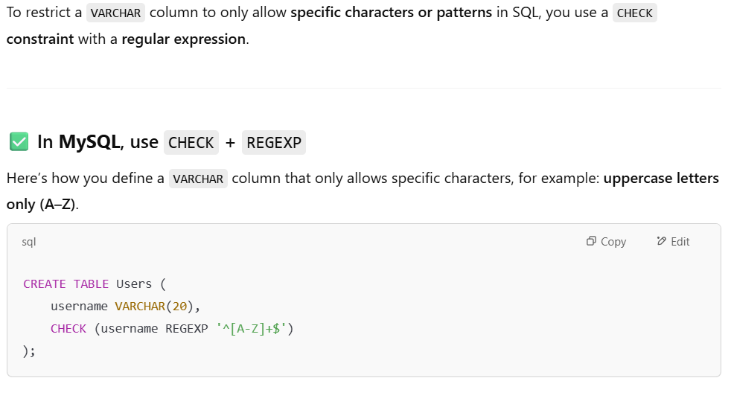

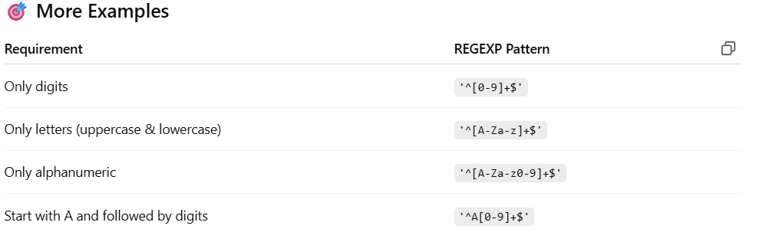

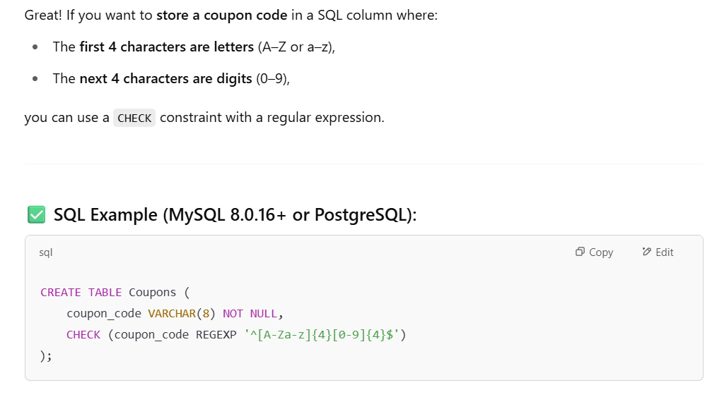

MUMBAI_CITY - MVRK0000001

PUNE - MVRK0000002

NAGPUR - MVRK0000003

THANE - MVRK0000004

NASHIK - MVRK0000005

HYDERABAD - MVRK0000006

RANGA_REDDY - MVRK0000007

MEDCHAL_MALKAJGIRI - MVRK0000008

WARANGAL - MVRK0000009

NIZAMABAD - MVRK0000010

KHAMMAM - MVRK0000011

CHENNAI - MVRK0000012

COIMBATORE - MVRK0000013

MADURAI - MVRK0000014

TIRUCHIRAPPALLI - MVRK0000015

SALEM - MVRK0000016